# Creating New Folder

To create a folder click on “+ Create” a button and choose the “New folder” option. A window will appear with input for the new folder’s name. Enter the desired name for the folder and click “Ok”. New folder will appear in your current location, and you will be taken straight into it.

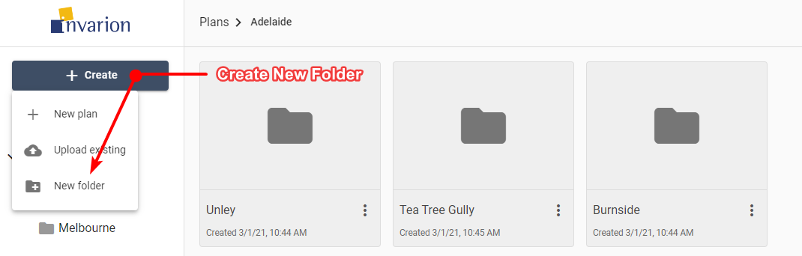

Create New Folder

**Notes:**

* You can change folder’s name at any time using rename option in the folder’s context menu on folder’s details.
* You can’t create a folder inside Home, All Plans or Shared with Me section.